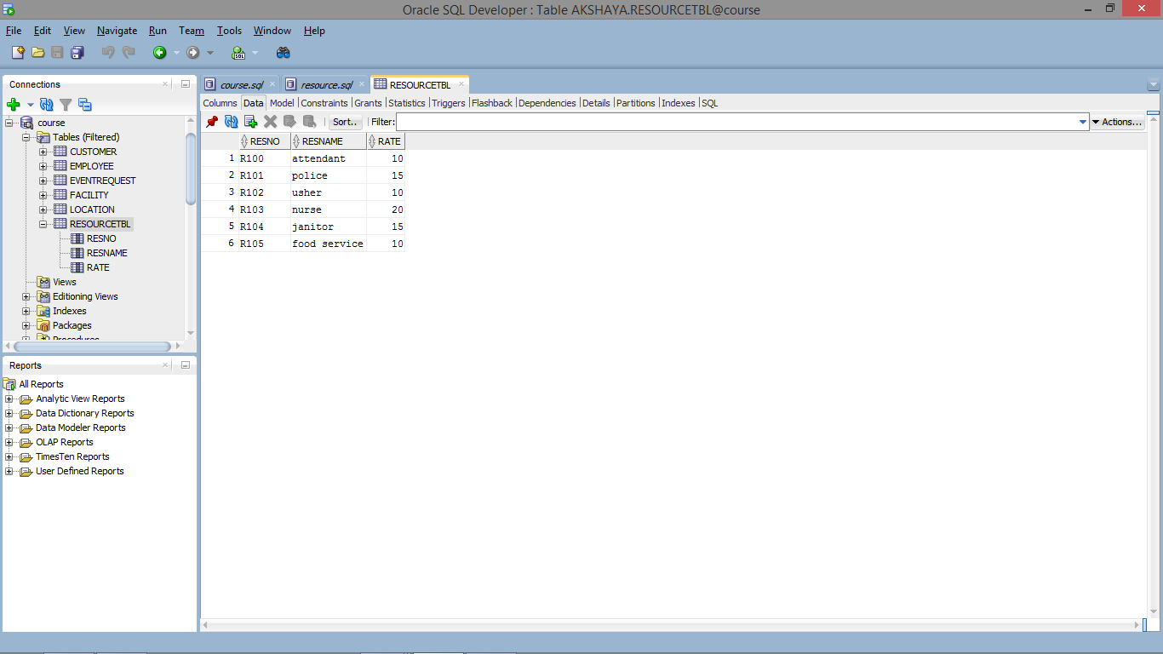

CREATE TABLE ResourceTbl

(

ResNo CHAR(8) PRIMARY KEY NOT NULL,

ResName VARCHAR(50) NOT NULL,

Rate DECIMAL(8, 2) NOT NULL,

CONSTRAINT chk_Rate CHECK (Rate > 0)

);

Insert into RESOURCETBL (RESNO,RESNAME,RATE) values ('R100','attendant',10);

Insert into RESOURCETBL (RESNO,RESNAME,RATE) values ('R101','police',15);

Insert into RESOURCETBL (RESNO,RESNAME,RATE) values ('R102','usher',10);

Insert into RESOURCETBL (RESNO,RESNAME,RATE) values ('R103','nurse',20);

Insert into RESOURCETBL (RESNO,RESNAME,RATE) values ('R104','janitor',15);

Insert into RESOURCETBL (RESNO,RESNAME,RATE) values ('R105','food service',10);